Complete Monthly Debt Figures Spreadsheet  - [FC2011/08660](el://FC2011%2f08660?db=WW&open) as per instructions attached

And then prepare Board Report (copy of previous attached)

Once completed email to Steve K to have placed into RM (records manager) ready for the Board Meetings

**Monthly Debt Figure Spreadsheet & Board Report Instructions**

* Produce a new tab for Month (right click – move or copy…. tick Create a copy)

Aquastats – Trial Balance for selected month

* right click copy all row & place into spreadsheet at line 7 over the top of the heading
* Once data entered into the Notes Tab for the month you can start working on the other tabs but you need to be working from the right to left

**Monthly Summary Tab**

* instructions for rural debt to right side of the page
* Instructions for parked debt to right side of the page
  + **Rural Debt**: In Aquastats, Select by Trial Balance, Show Values by ‘ Billing Type’, Trial Balance Options: ‘Ageing’, Display Options: "90 Days" "120 Days" and "120+ Days"
  + Hit Enter - highlight the rowe for ‘Rural’, right click, copy selected rowe and paste over field GT3 on the main spreadsheet.
  + Graphical user interface, application, Word

    Description automatically generated
  + **Parked Debt**: Aquastats, Trial Balance, Show values by ‘debt stream’, Trial Balance Option ‘ Ageing’, Display Options: "90 Days" "120 Days" and "120+ Days"
  + Hit Enter - highlight the rowe for ‘Parked Debt’, right click, copy selected rowe and paste over field GT10 on the main spreadsheet.
  + 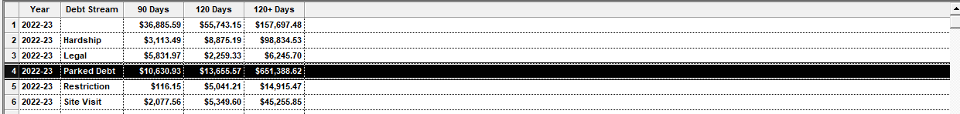
  + Copy & paste the rural & parked debt figures from the right screen shot below into the section shown in the left screen shot
  + 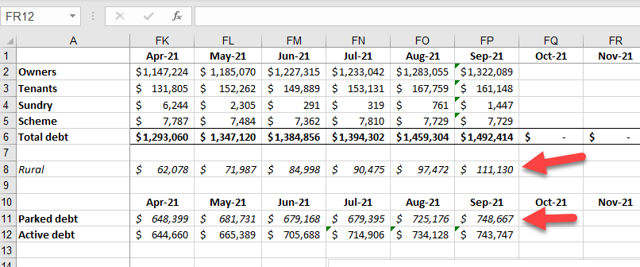 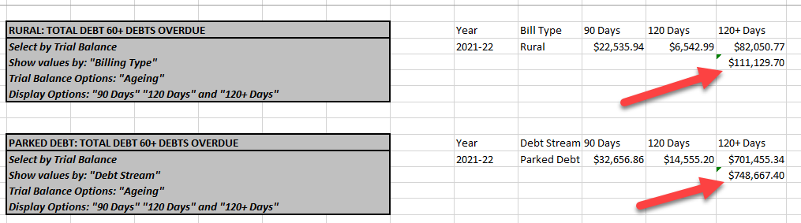
  + In the left screen shot: drag the formula from previous month to the current month for ‘Active Debt’
  + To get the owners, tenants sundry & scheme debt into the highlighted fields below, click & drag the formula for the previous month for the owner across to the current month. Amend the formula to suit the current month (So that it brings in the information from the ‘Notes – Dec22’ (field B14 – B17). Once the formula for the owner is correct, drag that formula down for the tenant, Sundry & Scheme over the other blank fields. The amounts in the current month’s tab should match the monthly summary tab.

* + - 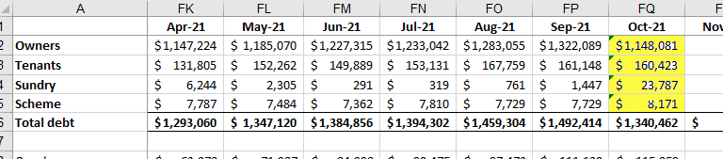

**Monthly Summary:**

* The data for field B141 (Oct-21, 60-90d) is the summary of the tab for the current month (i.e Notes – Oct21) See next 2 screen shots
* 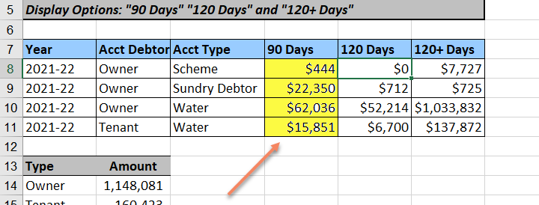

**Monthly Performance**

* Highlight the field for the previous month’s 60-90 day and drag it down into the current month. This will muck up your formula and you will need to correct it: =SUM('Notes - Dec22'!D8:D11) - =SUM(current month’s tab’! D8:D11)
* Once the formula for column B is correct, drag this formula across to columns C & D
* Columns F-I show the difference in debt for each month
* Drag the formula in field G140 down to G141
* Drag the formula in fields H139 & I139 down to
* Repeat these steps for the next 120+ table
* Highlight the data for the monthly change & average monthly change and drag it down into the next row. The data in the Monthly change & Average monthly change will auto-populate
* Update the colour range to match the existing pattern

**Board Report:**

**Monthly Performance Tab**

**Categories Tab**

* copy data & table from previous month & paste below the previous month,
* Go to Aquastats – search by the highlighted categories & paste new data from this month’s AquaStats over old data (in the new table just pasted)

Aqua Stats - Trial Balance for selected month

* Open a copy of last month’s Board – Credit Management Report (if you don’t have this, Steve Kearns or Brad O’Connor will be able to give you a copy)
* On the top of the board report, change the date in the orange section to last day of previous month
* Go to previous Excel spreadsheet - [FC2011/08660](el://FC2011%2f08660?db=WW&open)
* Go to Monthly Summery Tab & Write down the $ amounts for Tenant Debt, Rural Debt, Parked Debt & Active Debt ready for the Board Report
* Table

  Description automatically generated
* Go to the board report
* Click & then right click onto the graph for Parked & Active debt
* Click Edit Data – small excel spreadsheet will come up
* 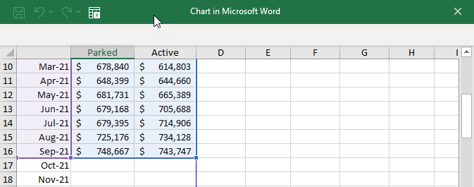
* Type the $ amounts for Parked & Active debt for the current month & drag the purple & blue section down.
* Repeat this for the ‘Tenant & Rural debt 60+ days overdue’ graph on the Word – Board Credit Management Report

**Board Report 5.1.2 (Credit Management Report)**

To complete the graphs for Total Debts 60+ Days Overdue & Tenant Rural Debts 60+ Days Overdue

* place cursor in the graph you want to update t

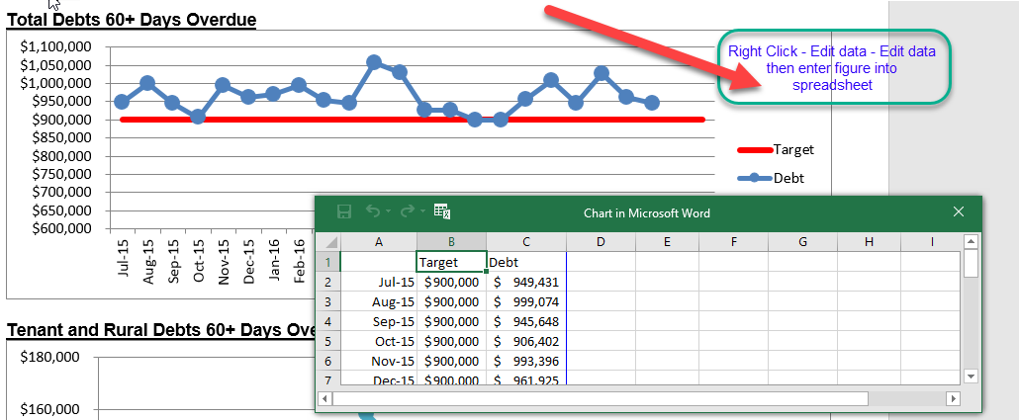

* Add some notes to the board report of any items that have arisen: i.e, if the Board Trend Data from Spreadsheet [FC2022/07019](el://FC2022%2f07019?db=WW&open) was over 150%, if there was a large jump in any debt, etc
* Save this report in your G’drive, so that you can continue to add data next month.
* Email the board report to Steve once completed for him to check everything / add additional notes and he will place it into Records Manager (RM) & forward to Brad O’Connor.

|  |  |
| --- | --- |
|  | **credit management reporT to 31 December 2022** |

**Total Debts 60+ Days Overdue**

**Tenant and Rural Debts 60+ Days Overdue**

The active debt has decreased due to the reversal of the Parks Victoria invoice for the 12 Apostles Project. Andrew Jeffers and Parks Victoria have negotiated a new cost of $550,000, for which a new invoice has been raised. As this charge is not yet due, it has not been shown in this report.

In addition, a number of properties with caveats have been sold during December 2022, which has resulted in large overdue accounts being paid.

**Report prepared by**

**Ulrike Hulin**

**Customer Relations Coordinator (Collections)**